**Audio and Video (Module 9)**

1. Create a custom video player with 50% width and 30% height of webpage. Video should start playing automatically when the webpage is loaded. Client should be able to replay the video at any point of time and will also able to see the full screen video. Customize the player accordingly.

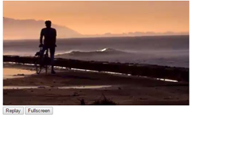

1. Embed an audio in your HTML document with customized buttons as follows:
2. volume increase button
3. volume decrease button
4. play/pause button button

